INDEX

PYTHON PROGRAMMING NOTES

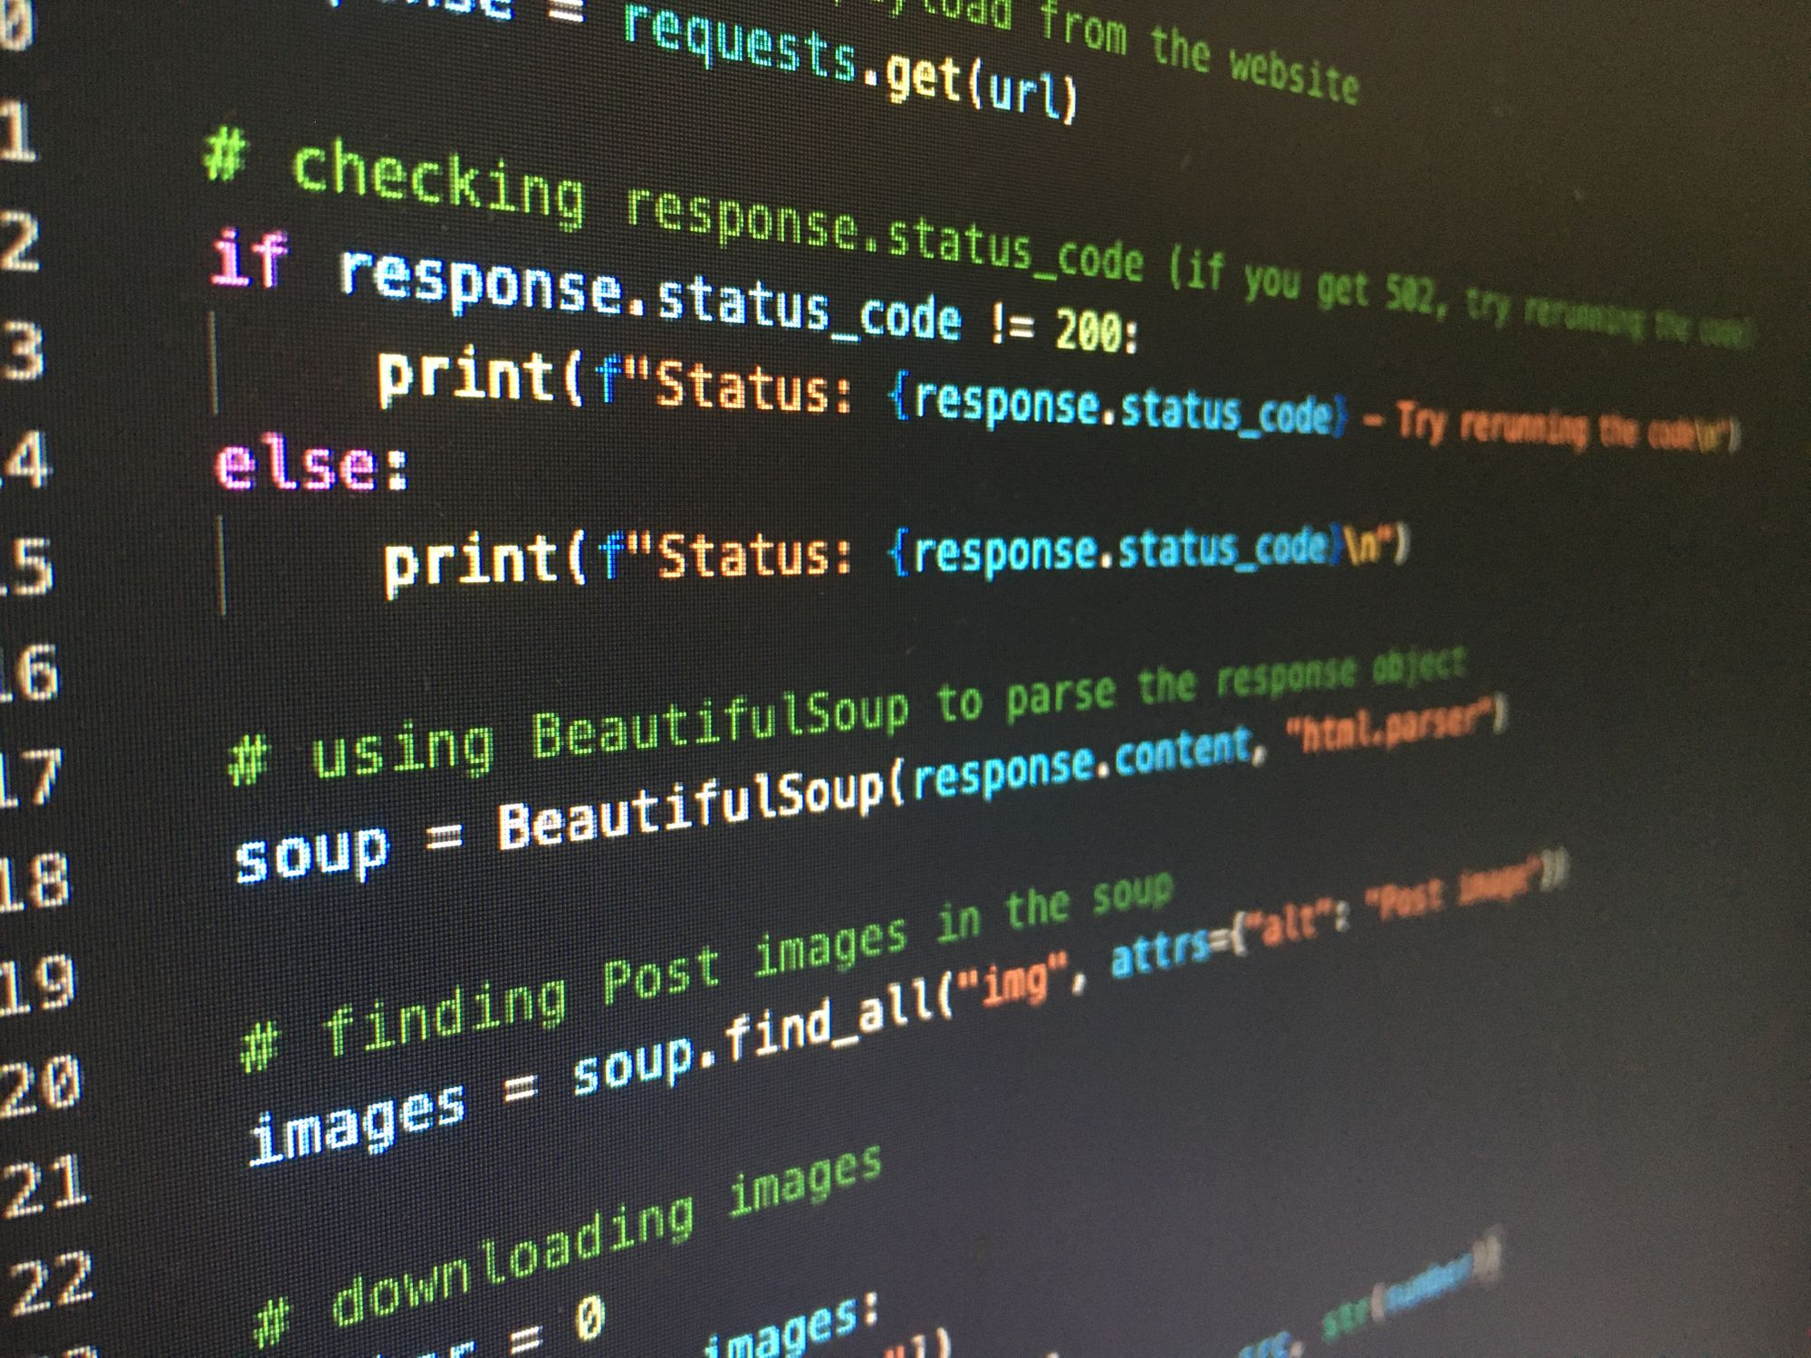
CHAPTER NO. CHAPTER NAME PAGE NO.

CHAPTER 1. Modules, Comments and pip 1

CHAPTER 2. Variable and Database 3

CHAPTER 3. Strings 6

CHAPTER 4. Lists and Tuples 9

CHAPTER 5. Dictionary and Sets 11

CHAPTER 6. Conditional Expression 14

CHAPTER 7. Loops in Python 17

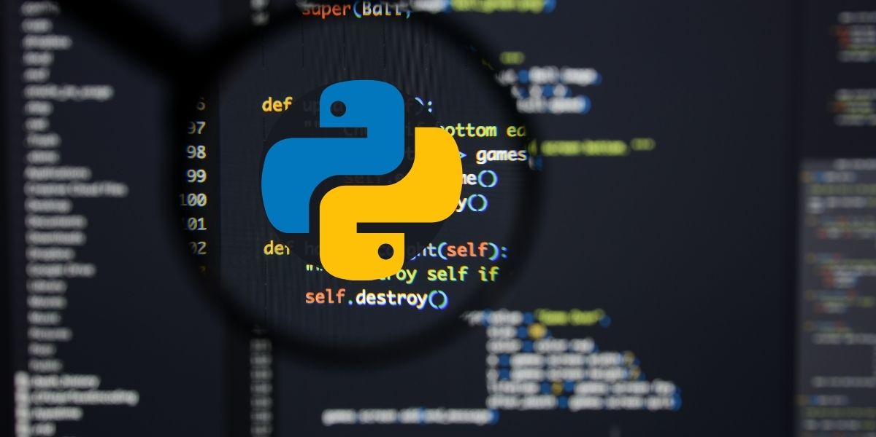
CHAPTER 8. Function and Recursion 21

CHAPTER 9. File I/O 23

CHAPTER 10. Object Oriented Programming 28

CHAPTER 11. Inheritance and more on OOPs 32

CHAPTER 12. Advance Python 1 36

CHAPTER 13. Advance Python 2 39

